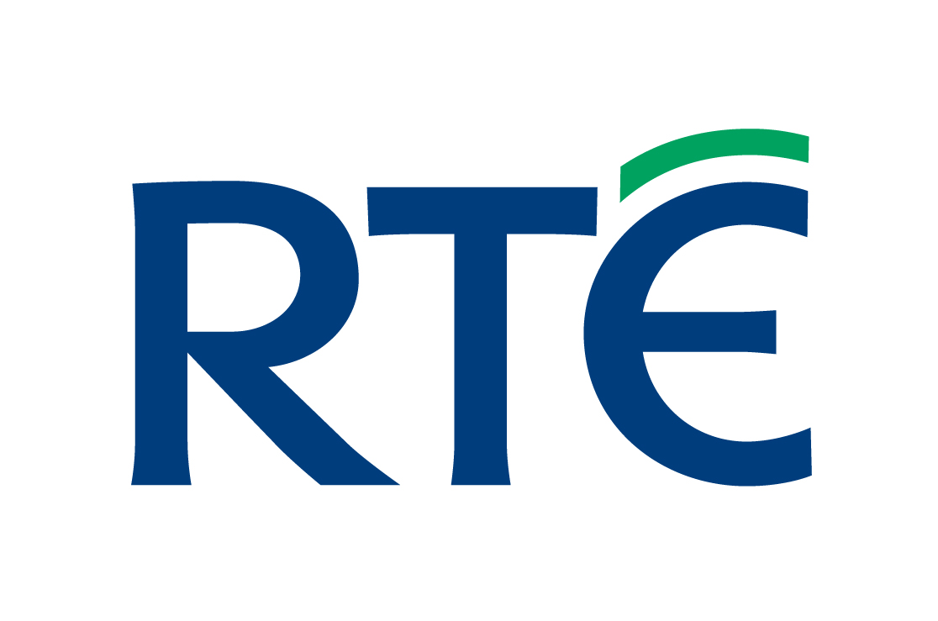
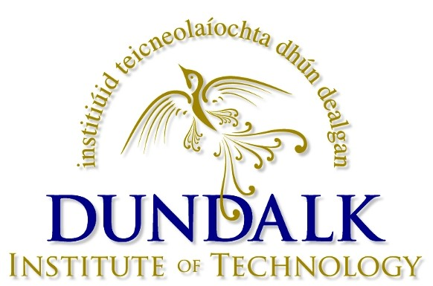
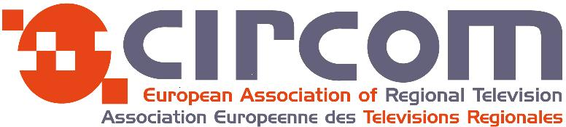

APPLICATION FORM

“MOJO”
Mobile Journalism Workshop

Dundalk, Ireland 16th – 22nd May 2015
NB: Arrival and departure dates are 15th and 23rd May 2014

NB: PLEASE READ THE FOLLOWING NOTES CAREFULLY BEFORE SUBMITTING YOUR APPLICATION

Technology is regularly changing our approach to newsgathering. The use of smart-phones for gathering material has increased considerably in recent years and they are being used to provide content that requires a quick turnaround for websites and for when traditional crews may not be available. They are also being used to edit stories, file transfer back to stations and even provide live broadcasts in difficult situations.
CIRCOM is providing a workshop for journalists that will give them an opportunity to learn the techniques and workflow when using a mobile phone. Journalists need to have the knowledge and professional skills in order to provide material that is useful for transmission, not just for TV, but also for radio and on-line services.

The main objectives are:

- To give participants training to a level where they are competent in the use of smart phones for filming, recording audio, file transfer and live transmissions.
- To give participants experience in using a laptop and/or ipad editing software to make a news package.
- To learn how to develop story ideas within the limitations of an iphone.
- To get to know the hardware, software and apps that are available to them and how to use them creatively.
- To understand the workflow in order to avoid mistakes.
- To give participant’s the necessary skills and confidence to work with a smart phone when appropriate.

By the end of the workshop it is expected that delegates will have produced a story located in the Dundalk area of 2 minutes duration.
The workshop will be 5 working days and will be restricted to 12 participants only.
The workshop will begin at 09.30, Saturday 16th May and end at 17.00 on Wednesday 20th May. After the workshop the delegates will attend the Circom Annual conference where they will be able to make reports and attend the most interesting sessions and debates concerning regional television in Europe.

The workshop will take place at the:

Dundalk Institute of Technology,
Dublin road, Dundalk, County Louth, Ireland
https://www.dkit.ie

CIRCOM provides the training free of charge for delegates from member stations and will also provide accommodation with breakfast for the 12 delegates, from Friday 15th May (check-in) to Saturday 23rd May (check out), at the:

Crowne Plaza Hotel,
Inner Relief Road, Dundalk, Co. Louth, Ireland
Tel: +353 42 939 4900
http://www.crowneplaza.com/hotels/gb/en/dundalk

There are quite a few cheap flights to Dublin and there is a bus service from Dublin Airport to the Dundalk Institute/Crowne Plaza Hotel. Travel time is approximately 45 minutes. Travel costs are your own responsibility and NOT paid by CIRCOM.

Upon completion of the workshop delegates will be registered as delegates for the CIRCOM Annual Conference taking place on the DKIT campus.

It is important that applications are received from journalists and stations who are committed to the role of the mobile journalist and who will be able to work and be supported as Mojo users when they return from the workshop. The training will be conducted in English and it is important that applicants have a good working knowledge of the language.

Because the workshop is of an intense nature, and requires a great deal of commitment from trainers and participants alike, priority will be given to those people, who show a good degree of commitment to working as a Mobile Journalist by being able to provide their own equipment. It is recommended that participants have their own smart phones, preferably iphone 4s/5/5s. Although we do not wish to endorse one product against another, we highly recommend that participants arrive with an Apple iphone. There are very good reasons for this and the main one being that the iphone is way ahead in the support provided through specifically developed hardware and software.
CIRCOM will provide some ipad editing facilities and will welcome anybody using their own ipads with editing software. It is possible to edit with an iphone and this is encouraged. We will also be sending out an essential apps and equipment list to all delegates accepted on the workshop and hope that they will be able to purchase the apps and some of the equipment and before the start of the course.
We will have some spare smart-phones and equipment available but only if necessary.
NB: Please complete the following survey in order that we can organise equipment accordingly: http://goo.gl/kxnm1G

As part of the application process applicants are expected to research and submit a story idea that they would like to film in the Dundalk region. The story will make up part of their course work and could be of interest to the audience in their home country as well as to other Circom member stations.

NB: It is our experience that those journalists who prepare or research stories prior to arriving in Dundalk will find that they will have more time and less stress when it comes to the production of their story. *****Be warned*****

Selection of all applicants will be at the discretion of CIRCOM, but every effort will be made to ensure that there will be 12 countries represented on the workshop.

Only complete the application form below if you have read and understood the above information and have also received the approval of your line manager and CIRCOM National Co-ordinator.

We are anticipating that this innovative workshop, providing for the future development in newsgathering options, will prove to be a popular one for our member’s news departments.

Once we have received 12 applications from 12 different member stations, the application process will close. This will allow successful applicants to make their travel arrangements sooner rather than later and take advantage of cheaper travel costs.

It is highly recommended that you make your application as soon as possible.

APPLICATION FORM

Mobile Journalism Workshop – Dundalk 2015

PERSONAL DETAILS:

First name: Surname:

Job Title:

Job description:
.
Work duties and experience:

Company Name:

Company Address:

Mobile Telephone Number:

Your email address:

Name of your Circom Regional National Co-ordinator:

National Co-ordinator email address:

The name and email address of your Line Manager:

Spoken languages NB: Applicants must have a good working knowledge of the English language:

Do you need a “Letter of Invitation” for a visa application?

Any special requirements:

Have you completed the survey accompanying this application?
http://goo.gl/kxnm1G

Please submit an idea for a news item of 2 minutes duration

1:

PLEASE RETURN APPLICATION BY EMAIL TO:

Karol Cioma, CIRCOM Regional Training Project Manager
TEL: +44 1286 871144
MOB: +44 7711 731688
EMAIL: k.cioma@btopenworld.com

DEADLINE: First come first served but closing on

Monday 13th April 2015

N.B. All applicants must have personal insurance cover for public liability, accident, sickness and loss of property.
Accommodation includes breakfast but does not include lunch, evening meals or personal extras such as drinks and telephone calls.
Delegates will be invited to receptions organised by RTE during the conference.
All travel costs to be paid by applicant or member station.

Please note that all applicants will be expected to attend the workshop in Dundalk and the CIRCOM conference that will also be a part of the workshop training.

